 | MATHEMATICS:SPECIALIST 3 & 4  SEMESTER 2 2018  TEST 4  Calculator Free
Reading Time: 2 minutes Time Allowed: 25 minutes
Total Marks: 24

Question 1 (6 marks)

(a) Use the substitution 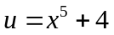to evaluate (3 marks)
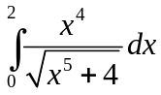 .

(b) Use the substitution 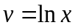 to determine the value of  if
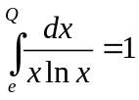. (3 marks)

Question 2 (6 marks)

(a) Express 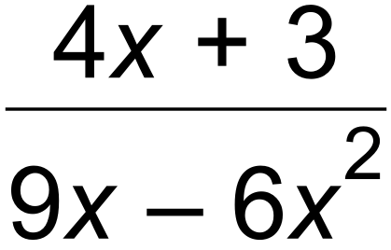 in the format 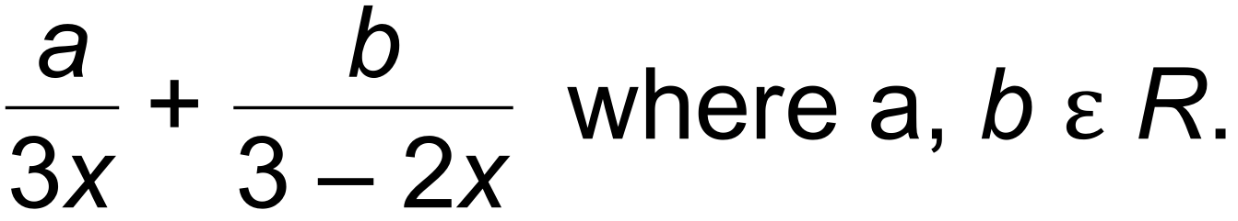 (3 marks)

(b) Hence, determine 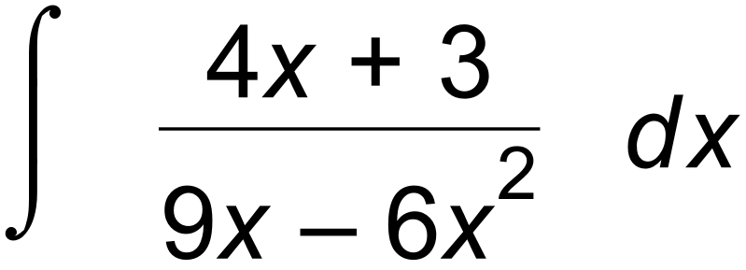. (3 marks)

Question 3 (8 marks)

Evaluate each of the following integrals.

(a) 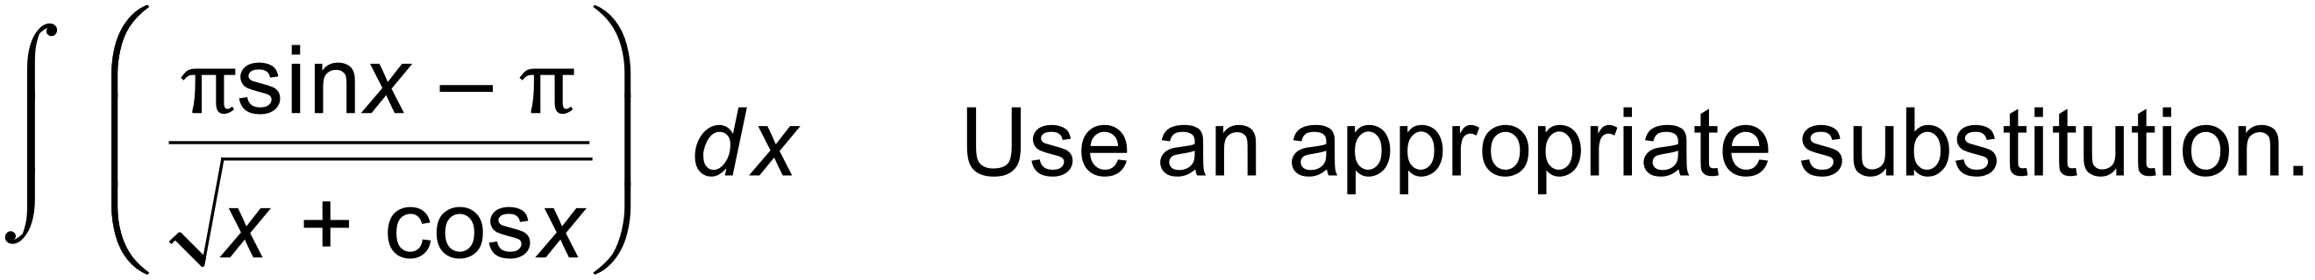 (4 marks)

(b) 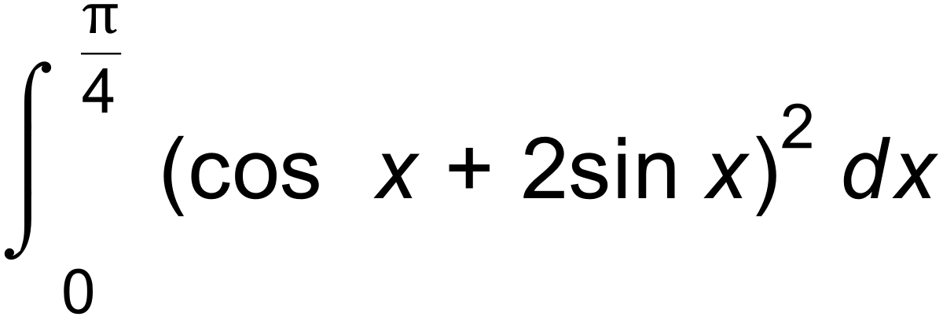 (4 marks)

Question 4 (4 marks)

Consider the area between the curves 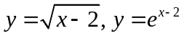 and the lines 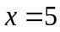and 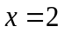 as shown below.
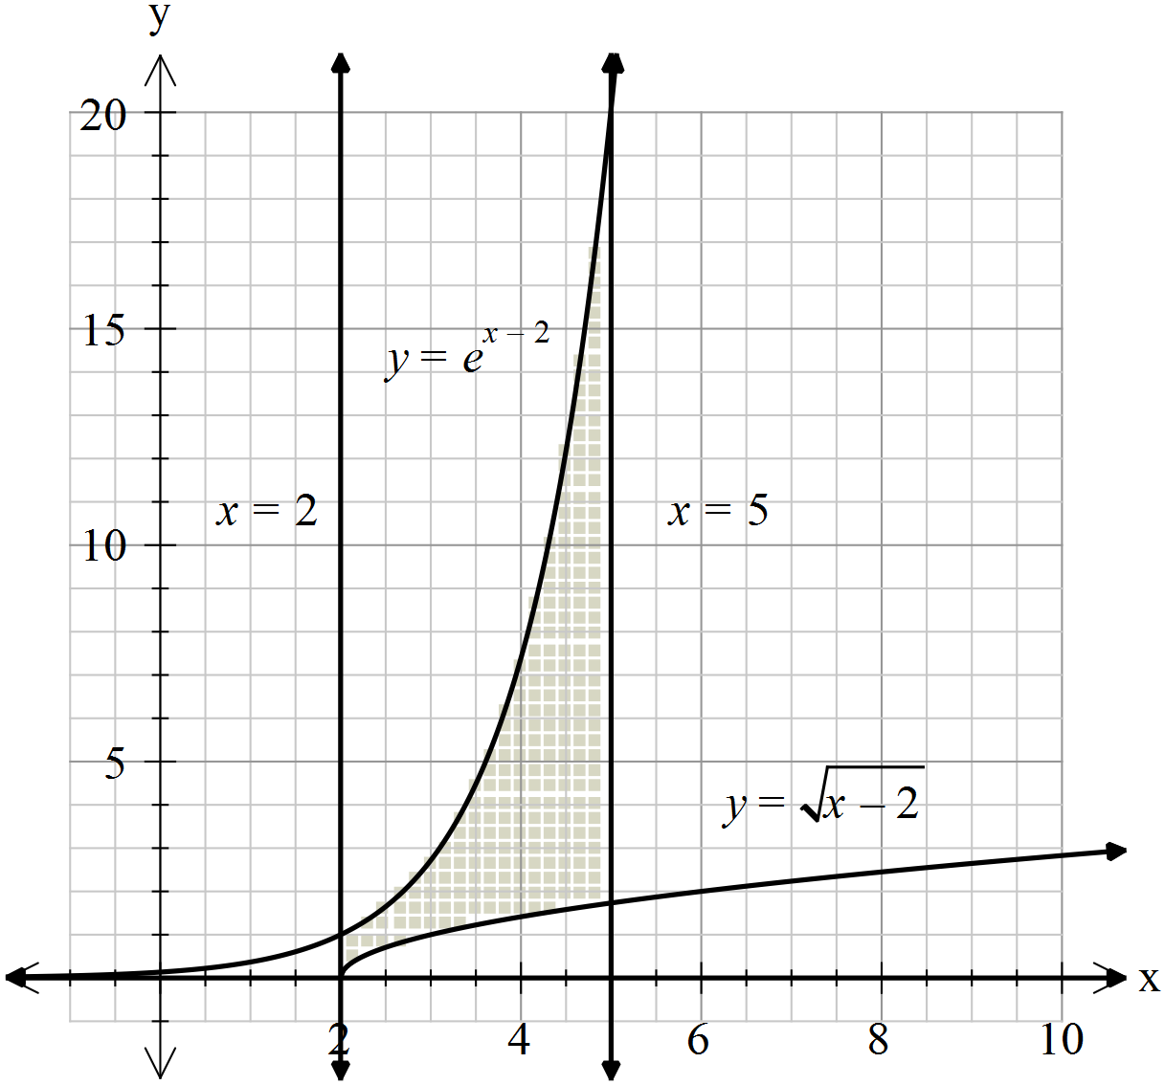

Calculate the area shown above, giving your answer in its simplest form.

MATHEMATICS:SPECIALIST 3 & 4
SEMESTER 2 2017
TEST 4
Calculator Assumed
Reading Time: 2 minutes Time Allowed: 30 minutes
Total Marks: 26

Question 5 (5 marks)
Part of the graph of is shown below.

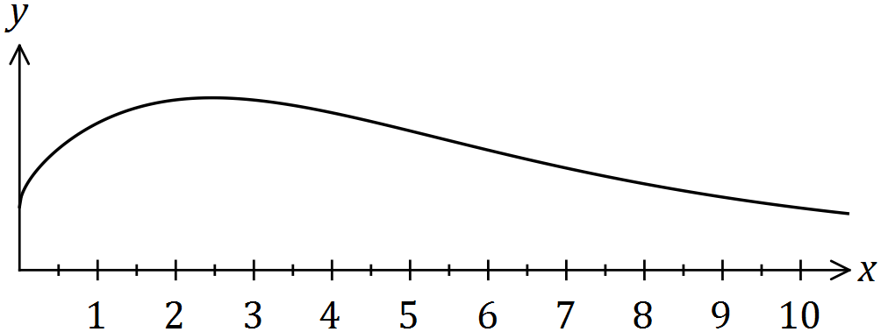

(a) Use numerical integration with three equal width trapeziums to estimate the area between the curve, the -axis, the -axis and the line . (4 marks)

(b) Briefly explain how your estimate in (a) would change if thirty trapeziums were used.
(1 mark)

Question 6 (8 marks)
The velocity vector of a small body at time seconds is ms⁻¹. Initially, the body has position vector .

(a) Determine the acceleration vector for the body when . (2 marks)

(b) Show that the maximum speed of the body is ms⁻¹. (3 marks)

(c) Determine the distance the body travels between and the first instant after this time that the body returns to its initial position, rounding your answer to the nearest cm.
(3 marks)

Question 7 (8 marks)
The position vector of a boat motoring on a lake is given by , where is the time, in hours, after it leaves and distances are in kilometres. The path of the boat is shown below, where the shoreline is represented by the line .

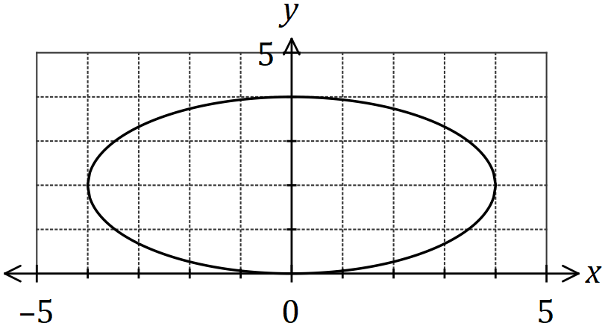

(a) Express the path of the particle as a Cartesian equation. (3 marks)

(b) On the graph above, mark the position of the boat when it is first km from the shoreline and indicate the direction it is travelling. (1 mark)

(c) Determine the speed of the boat when it is first km from the shoreline. (4 marks)

Question 8 (5 marks)
Part of the graph of is shown below.

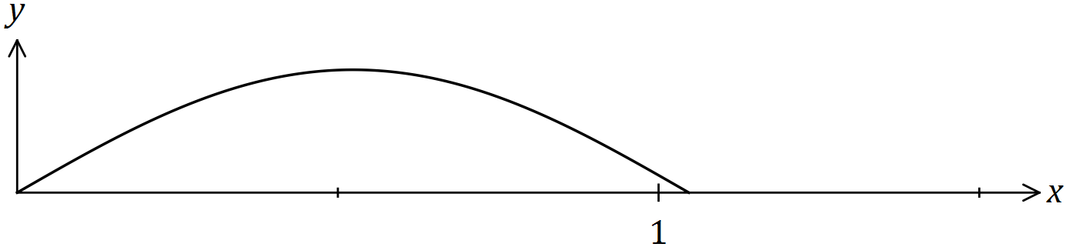

Show that when the part of the curve between and is rotated about the axis, the volume of the solid generated is . Clearly indicate all trigonometric identities used.

